1. Architecture Approaches
Approach A: The "Agentic Data Product" Mesh (Recommended)
This approach treats each data source as an autonomous node managed by an LLM-based Agent. Instead of static ETL scripts, agents dynamically map source schemas to a unified G2P model.
- Best for: Rapidly scaling to new, unstructured sources (e.g., scraping research PDFs or clinical trial registries).
- Key Tech: LangGraph, PydanticAI, Vector Databases.
Approach B: Serverless Event-Driven Lakehouse
A robust, highly scalable architecture using managed cloud services. Data flows from sources into a Medallion Architecture (Bronze/Silver/Gold) using Delta Lake or Iceberg.
- Best for: High-volume production environments requiring strict audit trails, HIPAA compliance, and versioned datasets.
- Key Tech: AWS Glue/Databricks, S3, Apache Iceberg.

2. High-Level Technical Design (Approach B)
Data Flow & Processing
- Ingestion (Bronze): Scheduled Lambda functions or Airflow operators fetch JSON/CSV from VICC-compliant sources (CIViC, OncoKB, MOAlmanac).
- Harmonization (Silver): PySpark jobs normalize variants using the GA4GH VRS (Variation Representation Specification) and standardize diseases using MONDO/EFO ontologies.
- AI Enrichment: A GenAI NER (Named Entity Recognition) service (via Amazon Bedrock or Vertex AI) scans PubMed abstracts linked in the data to extract evidence "strength" or new associations not yet in the structured feed.
- Serving (Gold): Cleaned data is indexed in OpenSearch for low-latency search and stored in a Graph Database (Amazon Neptune) to allow complex relationship queries (e.g., "Find all drugs targeting this pathway in Lung Cancer").
The Cloud Stack (AWS Example)
Component | Tech Stack
Orchestration | AWS Step Functions / Managed Airflow (MWAA)
Compute | AWS Glue (Spark) & AWS Lambda
Storage | Amazon S3 (Data Lake)
Search Engine | Amazon OpenSearch
Metadata/Graph | Amazon Neptune (for Gene-Phenotype-Drug triples)
AI/LLM | Amazon Bedrock (Claude 3.5 Sonnet) for automated curation
API | FastAPI (deployed on App Runner) or GraphQL (AppSync)

3. Implementation Challenges & Solutions
Challenge | Modern Solution
Schema Drift: Source APIs change their JSON structure frequently. | Use Pydantic V2 for runtime validation and LLMs to auto-suggest ETL fixes when a schema break is detected.
Normalization: "BRAF V600E" might be written 5 different ways across sources. | Integrate with VICC Normalizer APIs and use an AI "fuzzy matcher" to map strings to standard HGVS/NCBI IDs.
Data Privacy (PHI): Handling sensitive patient-linked variants. | Implement Zero-Trust architecture; use AWS Nitro Enclaves for processing and strict Attribute-Based Access Control (ABAC).
Literature Overload: Too many new papers for manual curators. | Deploy an Agentic RAG (Retrieval-Augmented Generation) pipeline to pre-screen papers and flag high-impact G2P associations.

4. Small POC Concept (Python)
Below is a conceptual snippet for a modern "Harvester" that uses an LLM to normalize an incoming variant record from an unknown source format into a structured Pydantic model.

import instructor
from pydantic import BaseModel, Field
from openai import OpenAI

# 1. Define the standard G2P schema (Gold Layer)
class G2PAssociation(BaseModel):
gene_symbol: str = Field(..., description="Official HGNC Gene Symbol")
variant_hgvs: str = Field(..., description="Standard HGVS variant notation")
disease_context: str = Field(..., description="Mapped disease name (e.g., MONDO)")
evidence_level: str = Field(..., description="Evidence grade (A, B, C, or D)")

# 2. Use Instructor for structured LLM extraction
client = instructor.from_openai(OpenAI())

def ai_normalize_record(raw_input: str) -> G2PAssociation:
return client.chat.completions.create(
model="gpt-4o",
response_model=G2PAssociation,
messages=[{"role": "user", "content": f"Extract and normalize G2P data: {raw_input}"}]
)

# Example: Mapping a messy, unstructured string
unstructured_data = "Patient with a BRAF mutation at position 600 (Val to Glu) in a melanoma case. Strong evidence."
normalized = ai_normalize_record(unstructured_data)

print(normalized.model_dump_json(indent=2))

Repository Structure (g2p-aggregator-modern)
This structure follows a production-ready layout, separating the infrastructure, data processing, and API layers.
Plaintext
g2p-aggregator-modern/
├── data/
│ ├── raw/ # Bronze: Landing zone for JSON/CSV dumps
│ └── gold/ # Gold: Parquet/Delta files for serving
├── src/
│ ├── ingestion/ # Lambda/Airflow ingestion scripts
│ ├── processing/ # Spark/Glue harmonization logic
│ │ ├── transform.py # Main Spark job
│ │ └── normalizers.py # VICC/HGVS mapping logic
│ ├── enrichment/ # LLM/Bedrock integration
│ └── api/ # FastAPI / GraphQL serving layer
├── infra/ # Terraform or CDK templates
├── docker-compose.yml # Local dev environment (API + OpenSearch)
├── requirements.txt
└── README.md
2. Harmonization Layer: Spark Script (transform.py)
This script handles the heavy lifting of converting disparate sources into the GA4GH Variation Representation Specification (VRS) format.
Python
from pyspark.sql import SparkSession
from pyspark.sql.functions import col, udf, lit
from pyspark.sql.types import StringType

spark = SparkSession.builder.appName("G2PHarmonizer").getOrCreate()

# Mock VICC Normalization Logic (Simplified)
def normalize_variant(variant_str):
# In production, this would call a cache or the VICC Normalize API
# Mapping "BRAF V600E" -> "NC_000007.14:g.140753336A>T"
return f"vrs:sequence_variant:{variant_str.replace(' ', '_')}"

normalize_udf = udf(normalize_variant, StringType())

def process_civic_data(path):
df = spark.read.json(path)

# Standardizing schema to the "Gold" layer
harmonized_df = df.select(
col("gene").alias("gene_symbol"),
normalize_udf(col("variant")).alias("vrs_id"),
col("disease").alias("disease_name"),
col("evidence_level"),
lit("CIViC").alias("source")
).filter(col("evidence_level").isin(["A", "B"])) # Filter for high confidence

return harmonized_df

# Load and Merge Sources
civic_df = process_civic_data("data/raw/civic_dump.json")
# moalmanac_df = process_moalmanac_data("data/raw/moa_dump.json")

# Write to Gold Layer (Delta Lake)
civic_df.write.format("delta").mode("overwrite").save("data/gold/g2p_associations")

3. Serving Layer: FastAPI (main.py)
This provides a modern, high-performance interface for researchers or downstream bio-apps to query the aggregated data.
Python
from fastapi import FastAPI, Query
from typing import List, Optional
import pandas as pd

app = FastAPI(title="Modern G2P Aggregator API")

# In production, this connects to OpenSearch or Amazon Neptune
# Here we simulate a quick lookup from our Gold Parquet files
@app.get("/associations")
def get_associations(gene: str = Query(..., example="BRAF")):
df = pd.read_parquet("data/gold/g2p_associations")
results = df[df['gene_symbol'] == gene].to_dict(orient="records")
return {"count": len(results), "data": results}

@app.get("/health")
def health_check():
return {"status": "online", "cloud_stack": "AWS/Serverless"}

4. Local Deployment (Docker Compose)
To allow the interviewers to run your POC locally without cloud credentials, provide this docker-compose.yml.
YAML
version: '3.8'
services:
api:
build: .
ports:
- "8000:8000"
volumes:
- ./data:/app/data
environment:
- DB_PATH=data/gold/g2p_associations

opensearch:
image: opensearchproject/opensearch:latest
environment:
- discovery.type=single-node
ports:
- "9200:9200"
5) Flow chart for the architecture

External APIs / Files / Research DBs
↓
Ingestion Layer (Batch + Streaming)
↓
Raw Data Lake (S3/GCS)
↓
Processing Layer (Spark/Flink)
↓
Curated Storage (Warehouse + NoSQL)
↓
AI Layer (NLP, embeddings)
↓
API Layer (FastAPI)
↓
Frontend / Consumers

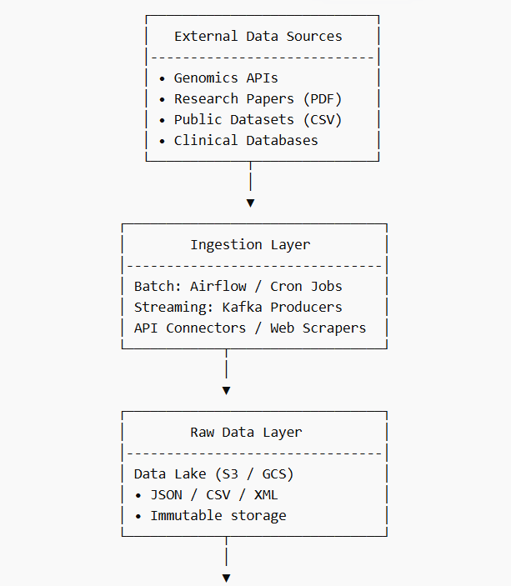
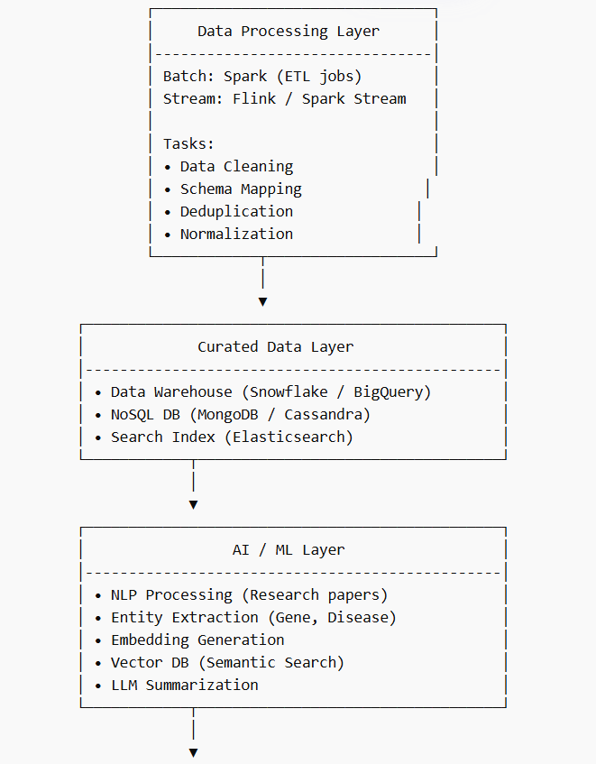
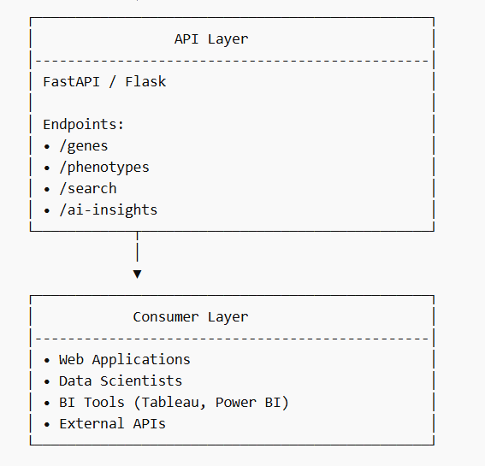

Coding Part

import openai
from pydantic import BaseModel, ValidationError
from typing import Dict, Any

class G2PEvidence(BaseModel):
gene_symbol: str = Field(..., description="Normalized HGNC Gene Symbol")
variant: str = Field(..., description="Variant notation, e.g., V600E")
phenotype: str = Field(..., description="Disease or condition")
evidence_level: str
source: str

def ai_normalize_gene(raw_gene: str) -> str:
"""
Simulates using an LLM to normalize non-standard gene names.
e.g., 'HER2' -> 'ERBB2'
"""
# In production, you'd use an OpenAI/Bedrock call here.
mapping = {"HER2": "ERBB2", "p53": "TP53"}
return mapping.get(raw_gene.upper(), raw_gene.upper())

def process_raw_record(raw_data: Dict[str, Any]) -> G2PEvidence:
try:
# 1. Step: Basic extraction
gene = raw_data.get("gene", "Unknown")

# 2. Step: AI/Lookup Normalization
normalized_gene = ai_normalize_gene(gene)

# 3. Step: Validation via Pydantic
record = G2PEvidence(
gene_symbol=normalized_gene,
variant=raw_data.get("variant_description", "N/A"),
phenotype=raw_data.get("condition", "Unknown"),
evidence_level=raw_data.get("level", "Tier III"),
source=raw_data.get("source_id", "Internal")
)
return record
except ValidationError as e:
print(f"Data Quality Error: {e}")
raise

# Example Usage
raw_input = {"gene": "HER2", "variant_description": "V600E", "condition": "Breast Cancer"}
final_record = process_raw_record(raw_input)
print(final_record.json())

Screen shots

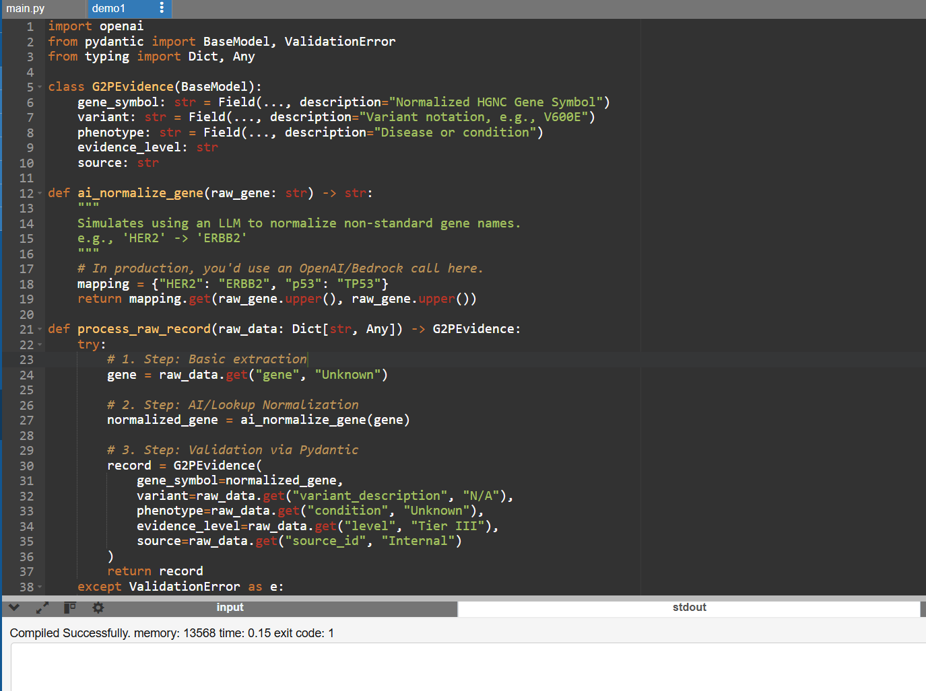
Output
